Server Output

Select operation mode (Server = 1, Peer = 2): 1
This process will operate as the Server.

Select the port that will be used for listening: 1111

The server is now active.
Peer 1 has connected!
Updating file index, adding: peer1file7
Updating file index, adding: peer1file4
Updating file index, adding: peer1file9
Updating file index, adding: peer1file3
Updating file index, adding: peer1file10
Updating file index, adding: peer1file6
Updating file index, adding: peer1
Updating file index, adding: peer1file2
Updating file index, adding: peer1file5
Updating file index, adding: peer1file8

***NEW INDEX***
peer1file7
peer1file4
peer1file9
peer1file3
peer1file10
peer1file6
peer1
peer1file2
peer1file5
peer1file8
**************

The peer(s) with peer1file4: 1 (A peer searched for the peer1file4 file)

Peer Output

Select operation mode (Server = 1, Peer = 2): 2
This process will operate as a Peer.

Select the IP address to connect to: 127.0.0.1
Select the port: 1111
Connection Established!

Please enter a command (Use ? for help): r

Adding file information to indexing server...
Updating file index, adding: peer1file7
Updating file index, adding: peer1file4
Updating file index, adding: peer1file9
Updating file index, adding: peer1file3
Updating file index, adding: peer1file10
Updating file index, adding: peer1file6
Updating file index, adding: peer1
Updating file index, adding: peer1file2
Updating file index, adding: peer1file5
Updating file index, adding: peer1file8
Operation complete.

Please enter a command (Use ? for help): s
Enter the file you are searching for: peer2file5
Peer ID(s) with file: Peer with ID # 0 (The lowest peer is 1, so this failed)
Please enter a command (Use ? for help): s
Enter the file you are searching for: peer2file6
Peer ID(s) with file: Peer with ID # 2
Please enter a command (Use ? for help): o
Enter the file you are trying to obtain: peer2file6

Free ebooks - Project GutenbergBook search · Book categories · Browse catalog · Mobile site · Report errors · Terms of useSome of the Latest BooksWelcomeQR CodeProject Gutenberg Mobile Site...........

peer2file6 has been copied.
Please enter a command (Use ? for help): quit
terminate called after throwing an instance of 'rpc::rpc_error' (This is not working properly)
what(): rpc::rpc_error during call
Aborted (core dumped)

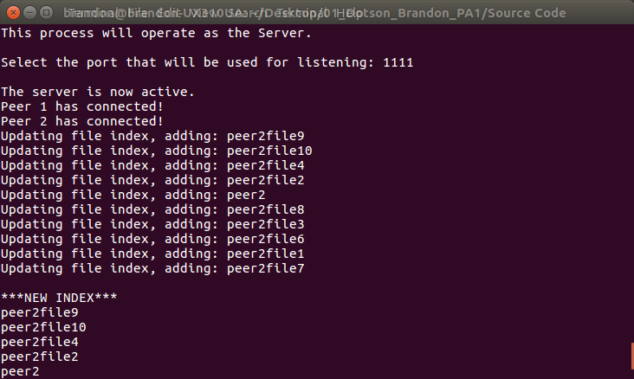
Figure 1: Server Output

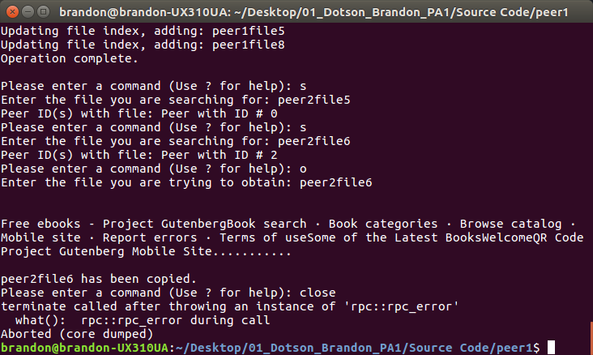
Figure 2: Peer Output

